
Lab Assignment: 01
Course: Information Security
Submitted to: Mam Ambreen
Submitted by: Attiqa
Reg no: Sp24-bse-050
Oct 12, 2025

Study Salsa20 Cipher and do the following activity
1. Write python code for your designed stream cipher approach for encryption decryption, you can use approach from more than one already developed ciphers as given in lab practice exercises.
2. Design and implement an adversarial attack approach for your proposed stream cipher approach.
PYTHON CODE:
from Crypto.Cipher import Salsa20
from Crypto.Random import get_random_bytes

def encrypt_message(key, nonce, message):
cipher = Salsa20.new(key=key, nonce=nonce)
return cipher.encrypt(message.encode())

def decrypt_message(key, nonce, ciphertext):
cipher = Salsa20.new(key=key, nonce=nonce)
plaintext = cipher.decrypt(ciphertext).decode()
print("Decrypted message:", plaintext)
return plaintext

def keystream_reuse_recover(known_plain: str, c_known: bytes, c_target: bytes) -> str:
x = bytes(a ^ b for a, b in zip(c_known, c_target))
recovered = bytes(a ^ b for a, b in zip(known_plain.encode(), x))
return recovered.decode()

if __name__ == "__main__":
p1 = "Hello teacher, this is Attiqa!"
p2 = "Secret: exam on Friday at 9am

key = get_random_bytes(32)
nonce = get_random_bytes(8)

print("Original message 1:", p1)
c1 = encrypt_message(key, nonce, p1)
print("Ciphertext 1 (hex):", c1.hex())
pt1 = decrypt_message(key, nonce, c1)

print()

print("Original message 2:", p2)
c2 = encrypt_message(key, nonce, p2)
print("Ciphertext 2 (hex):", c2.hex())
pt2 = decrypt_message(key, nonce, c2)

print("\n--- Keystream-reuse attack demo ---")
recovered_p2 = keystream_reuse_recover(p1, c1, c2)
print("Recovered p2:", recovered_p2)
print("Recovered equals original?", recovered_p2 == p2

OUTPUT OF CODDE:
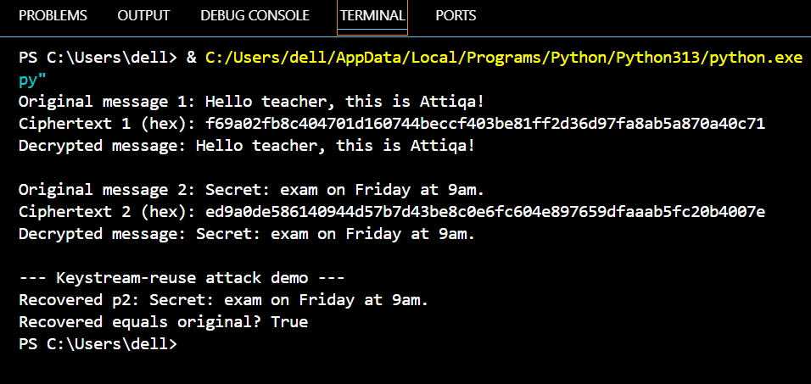
CODE EXPLANATION:

1. Purpose
This program demonstrates encryption and decryption using the Salsa20 stream cipher, and shows how reusing the same key and nonce can lead to a serious security weakness called a keystream reuse attack.
The program first encrypts and decrypts two messages correctly, then shows how an attacker can recover another message if the same key and nonce are reused.

2. Imports
from Crypto.Cipher import Salsa20
from Crypto.Random import get_random_bytes
These lines import the required tools from the PyCryptodome library.
- Salsa20 provides the stream cipher for encryption and decryption.
- get_random_bytes() is used to generate random keys and nonces securely.

3. Function: encrypt_message(key, nonce, message)
def encrypt_message(key, nonce, message):
cipher = Salsa20.new(key=key, nonce=nonce)
return cipher.encrypt(message.encode())
Purpose: Encrypt a plaintext string using Salsa20.
- A cipher object is created with the given key and nonce.
- The message is converted into bytes using .encode().
- The cipher XORs the plaintext with a random keystream to produce ciphertext bytes.
Output: Returns the ciphertext.

4. Function: decrypt_message(key, nonce, ciphertext)
def decrypt_message(key, nonce, ciphertext):
cipher = Salsa20.new(key=key, nonce=nonce)
plaintext = cipher.decrypt(ciphertext).decode()
print("Decrypted message:", plaintext)
return plaintext
Purpose: Decrypt the ciphertext using the same key and nonce.
- Salsa20 decryption works the same way as encryption (XOR with the same keystream).
- The decrypted bytes are converted back to text using .decode().
Output: Returns and prints the decrypted plaintext.
Decryption will only work if the same key and nonce are reused exactly as in encryption.

5. Function: keystream_reuse_recover(known_plain, c_known, c_target)
def keystream_reuse_recover(known_plain, c_known, c_target):
x = bytes(a ^ b for a, b in zip(c_known, c_target))
recovered = bytes(a ^ b for a, b in zip(known_plain.encode(), x))
return recovered.decode()
Purpose: Demonstrate how reusing the same keystream allows an attacker to recover another message.
Key idea:
- For a stream cipher:
ciphertext = plaintext XOR keystream
- If the same keystream is reused:
c1 XOR c2 = p1 XOR p2
- If the attacker knows p1, they can compute p2 = p1 XOR (c1 XOR c2).
Implementation:
- x = c_known XOR c_target
- recovered = known_plain XOR x → gives part of the target plaintext.
- The function returns the recovered text

Main program block
if __name__ == "__main__":
p1 = "Hello teacher, this is Attiqa!"
p2 = "Secret: exam on Friday at 9am."

key = get_random_bytes(32)
nonce = get_random_bytes(8)

print("Original message 1:", p1)
c1 = encrypt_message(key, nonce, p1)
print("Ciphertext 1 (hex):", c1.hex())
pt1 = decrypt_message(key, nonce, c1)

print()

print("Original message 2:", p2)
c2 = encrypt_message(key, nonce, p2)
print("Ciphertext 2 (hex):", c2.hex())
pt2 = decrypt_message(key, nonce, c2)

print("\n--- Keystream-reuse attack demo ---")
recovered_p2 = keystream_reuse_recover(p1, c1, c2)
print("Recovered p2:", recovered_p2)
print("Recovered equals original?", recovered_p2 == p2)

- What happens step-by-step:
  - Two plaintexts defined: p1 (attacker-known) and p2 (target).
  - A random 256-bit key and an 8-byte nonce are generated once.
  - p1 is encrypted to produce c1; the program prints c1 (hex) and decrypts it to verify correctness.
  - The same key and nonce are reused to encrypt p2 producing c2.
  - The attack function computes c1 XOR c2, then p1 XOR (c1 XOR c2) to recover p2’s overlapping bytes without needing the key.
  - And finally print the recovered p2 and checks whether the recovered text equals the original p2

